Application: Debugging Pair Sum (Redundant Comparisons)

CO2 AT3
CSA0619 – DESIGN AND ANALYSIS OF ALGORITHMS
Submitted by

M Yasodha Krishna (192472100)
Under the Supervision of

Dr. F. Mary Harin Fernandez
ABSTRACT
Pair Sum is a common problem in programming where the objective is to find two elements in an array whose sum equals a given target value. A brute-force approach compares every possible pair, but this results in many unnecessary and duplicate comparisons. This report identifies the inefficiencies in the given algorithm, explains the reason for redundant comparisons, presents an optimized solution, and analyzes its performance. The optimized algorithm improves efficiency while maintaining the correctness of the output.
INTRODUCTION
Debugging and optimization are important phases in software development. A program may produce correct results but still perform inefficiently due to poor algorithm design. The Pair Sum problem is an example where unnecessary comparisons increase execution time. By modifying the loop structure, redundant operations can be eliminated, resulting in a cleaner and more efficient implementation. This report demonstrates how the algorithm is optimized without affecting its correctness.
PROBLEM STATEMENT
The given brute-force Pair Sum algorithm checks every possible combination of array elements to determine whether their sum equals the target value.
for i in range(len(arr)):
for j in range(len(arr)):
if arr[i] + arr[j] == target:
return (i, j)
The given code has the following inefficiencies:
- It compares every element with every other element, including itself.
- It checks duplicate pairs such as (0,1) and (1,0).
- It also checks unnecessary pairs like (0,0).
- These redundant comparisons increase execution time.
Example:
For
arr = [2, 4, 6]
The code checks
(2,2)
(2,4)
(2,6)

(4,2)
(4,4)
(4,6)

(6,2)
(6,4)
(6,6)
The pair (2,4) and (4,2) are the same comparison.
OBJECTIVES
- To identify redundant comparisons in the given algorithm.
- To understand why duplicate comparisons occur.
- To debug the existing loop structure.
- To optimize the algorithm while maintaining correctness.
- To analyze the time and space complexity of the optimized solution.
EXISTING SYSTEM
The original algorithm uses two nested loops, where both loops start from index 0.
This causes:
- Comparison of an element with itself.
- Duplicate pair comparisons.
- Increased execution time.
- Unnecessary computational overhead.
Example:
Array:
[2, 7, 11, 15]
Comparisons performed:
(2,2)
(2,7)
(2,11)
(2,15)

(7,2)
(7,7)
(7,11)
(7,15)
The pairs (2,7) and (7,2) represent the same comparison and are therefore redundant.
PROPOSED SYSTEM
The optimized algorithm modifies the inner loop to begin from i + 1 instead of 0.
for i in range(len(arr)):
for j in range(i + 1, len(arr)):
This improvement:
- Eliminates duplicate comparisons.
- Prevents self-comparisons.
- Reduces the total number of comparisons.
- Maintains the correctness of the algorithm.
ALGORITHM
- Start.
- Read the array elements.
- Read the target value.
- Initialize the comparison counter.
- Traverse the array using the outer loop.
- Start the inner loop from i + 1.
- Check whether the sum equals the target.
- If found, display the pair and stop.
- Otherwise continue searching.
- If no pair exists, display "Pair Not Found".
- Stop.
IMPLEMENTATION
The optimized Pair Sum algorithm is implemented in Python using nested loops. The outer loop selects the first element, while the inner loop begins from the next element, avoiding duplicate and self-comparisons. A comparison counter is used to analyze the reduction in unnecessary operations.
_sum(arr, target):
comparisons = 0
print("\nSearching for Pair...\n")
for i in range(len(arr)):
for j in range(i + 1, len(arr)):
comparisons += 1
print("Checking Pair :", arr[i], "+", arr[j])
if arr[i] + arr[j] == target:
print("\nPair Found Successfully!")
print("First Element :", arr[i])
print("Second Element :", arr[j])
print("Indices :", i, j)
print("Target Sum :", target)
print("Total Comparisons :", comparisons)
return
print("\nPair Not Found")
print("Total Comparisons :", comparisons)
def main():
print("=" * 60)
print("DEBUGGING AND OPTIMIZATION - PAIR SUM")
print("=" * 60)
n = int(input("Enter Number of Elements : "))
arr = []
print("\nEnter Array Elements")
for i in range(n):
element = int(input("Element {} : ".format(i + 1)))
arr.append(element)
target = int(input("\nEnter Target Sum : "))
print("\nArray :", arr)
print("Target :", target)
pair_sum(arr, target)
print("\n" + "=" * 60)
print("Optimization Applied")
print("- Duplicate comparisons removed")
print("- Self comparisons avoided")
print("- Inner loop starts from i + 1")
print("\nTime Complexity : O(n^2)")
print("Space Complexity : O(1)")
print("=" * 60)
main()
SAMPLE INPUT
Enter Number of Elements : 5
Element 1 : 2
Element 2 : 7
Element 3 : 11
Element 4 : 15
Element 5 : 8
Enter Target Sum : 9
SAMPLE OUTPUT
PAIR SUM USING OPTIMIZED BRUTE FORCE
Searching for Pair...
Checking Pair : 2 + 7
Pair Found
First Element : 2
Second Element : 7
Indices : 0 1
Total Comparisons : 1
Time Complexity : O(n²)
Space Complexity : O(1)
OUTPUT SCREENSHOT
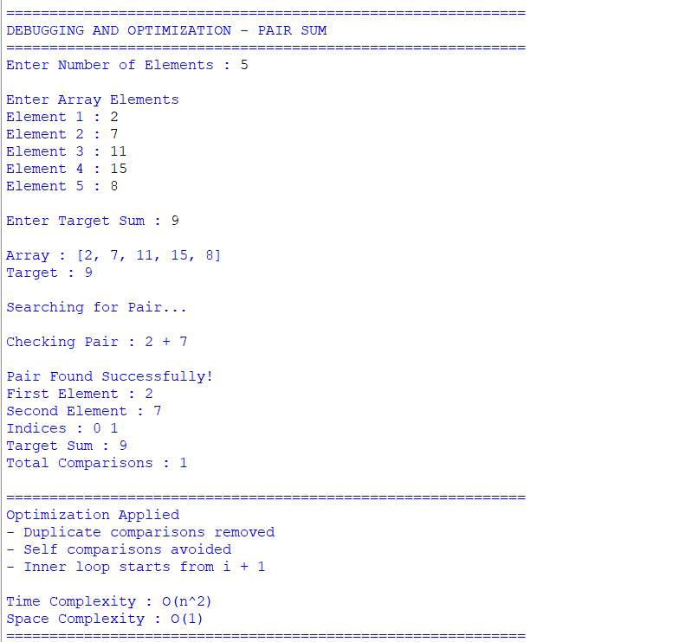
DEBUGGING ANALYSIS
The original algorithm checks every possible pair in the array, including comparisons where an element is compared with itself. It also evaluates duplicate pairs such as (a, b) and (b, a), even though both represent the same combination. These redundant comparisons increase the number of iterations without improving the result. By changing the starting index of the inner loop to i + 1, duplicate and self-comparisons are eliminated, reducing unnecessary computation.
OPTIMIZATION TECHNIQUE
The optimization is achieved by modifying the loop structure.
Original Loop
for i in range(len(arr)):
for j in range(len(arr)):
Optimized Loop
for i in range(len(arr)):
for j in range(i + 1, len(arr)):
This simple modification improves practical performance while preserving the correctness of the algorithm.
COMPLEXITY ANALYSIS
Parameter | Original Algorithm | Optimized Algorithm
Time Complexity | O(n²) | O(n²)
Space Complexity | O(1) | O(1)
Duplicate Comparisons | Yes | No
Self Comparisons | Yes | No

APPLICATIONS
- Pair Sum problems
- Financial transaction analysis
- Inventory management
- Data analytics
- Competitive programming
- Search-based applications
ADVANTAGES
- Eliminates redundant comparisons.
- Improves execution efficiency.
- Produces correct results.
- Easy to understand and implement.
- Reduces unnecessary iterations.
LIMITATIONS
- Still uses nested loops.
- Time complexity remains O(n²).
- Less efficient than hashing-based solutions for very large datasets.
CONCLUSION
The original Pair Sum algorithm contained unnecessary comparisons that increased computation time. By modifying the inner loop to start from i + 1, duplicate and self-comparisons were successfully removed. Although the overall time complexity remains O(n²), the optimization significantly reduces the number of comparisons in practice, making the algorithm more efficient while maintaining correctness.
REFERENCES
- Thomas H. Cormen, Introduction to Algorithms, MIT Press.
- Ellis Horowitz and Sartaj Sahni, Fundamentals of Computer Algorithms.
- Alfred V. Aho, John E. Hopcroft, and Jeffrey D. Ullman, The Design and Analysis of Computer Algorithms.
- Course Notes on Design and Analysis of Algorithms.

